Daily Recruitment Posts for IRB Study

Twitter Posts
Post 1
Living with Sickle Cell Disease in Florida? Help us understand how you manage pain at home! Join our University of Miami anonymous survey led by Noella Dietz, PhD (15-20 min, 18+). IRB-approved.
Take part: https://forms.gle/xNqc9nhtqPmFu6V5A
#SCD #SickleCell #HealthResearch
Post 2
Are you 18+ with SCD in Florida? Share your pain management strategies in our IRB-approved University of Miami study led by Noella Dietz, PhD. Anonymous, 15-20 min survey. Your voice matters!
Join here: https://forms.gle/xNqc9nhtqPmFu6V5A
#SickleCellAwareness #SCD
Post 3
Florida SCD community! We’re researching home-based pain management. If you’re 18+, take our anonymous, IRB-approved survey (15-20 min) to help improve care led by Noella Dietz, PhD, University of Miami study.
Start now: https://forms.gle/xNqc9nhtqPmFu6V5A
#SickleCell #PainManagement

Instagram Posts
Post 1
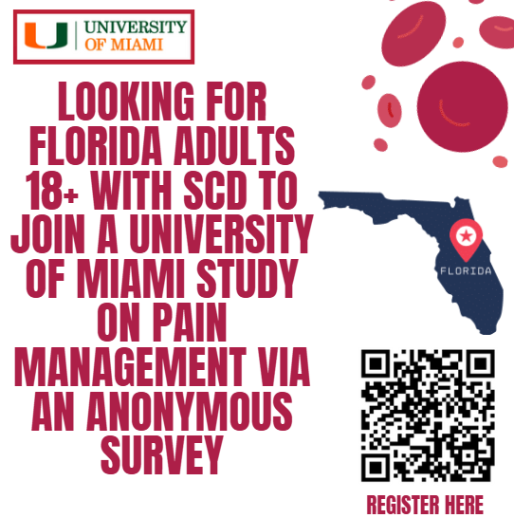
🌿 Do you manage Sickle Cell Disease pain at home? If you’re 18+ and in Florida, join our University of Miami research study! Take our anonymous, IRB-approved survey (15-20 min) to share your experience. Link in bio! #SickleCell #SCD #HealthResearch
https://forms.gle/xNqc9nhtqPmFu6V5A

Post 2
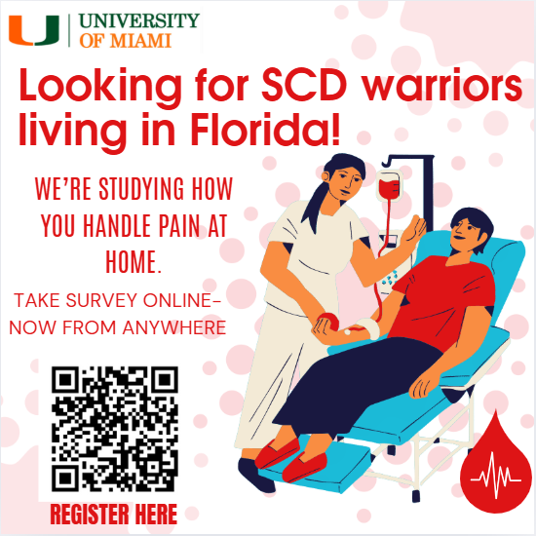
💙 SCD warriors in Florida! We’re studying how you handle pain at home. Adults 18+, take our 15-20 min anonymous survey for the University of Miami. IRB-approved. Your insights can shape better care! Link in bio. #SickleCellAwareness #SCDResearch
https://forms.gle/xNqc9nhtqPmFu6V5A

Post 3
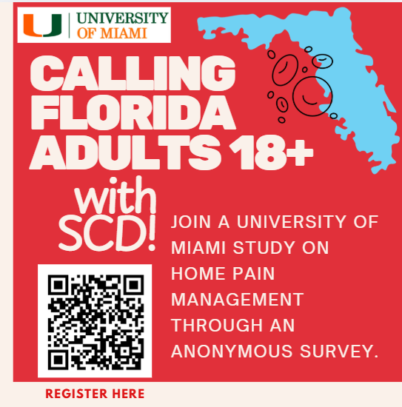
🩺 Living with SCD in Florida? The University of Miami wants to hear how you manage pain at home. Adults 18+, join our IRB-approved, anonymous survey (15-20 min). Help improve SCD care! Click the link in bio. #SickleCell #PainManagement
https://forms.gle/xNqc9nhtqPmFu6V5A

Instagram Threads Posts
Post 1
SCD community in Florida! Are you 18+? The University of Miami is researching how you manage pain at home. Take our anonymous, IRB-approved survey (15-20 min) to share your story. Your input can make a difference!
Join:https://forms.gle/xNqc9nhtqPmFu6V5A
#SCD #SickleCell

Post 2
Hey Florida SCD warriors! How do you handle pain at home? If you’re 18+, help us learn more through an anonymous, 15-20 min survey. University of Miami, IRB-approved. Your voice can improve care!
Take it here: https://forms.gle/xNqc9nhtqPmFu6V5A
#SickleCellResearch

Post 3
Calling adults 18+ with SCD in Florida! Share your pain management experiences in our University of Miami study. It’s a quick, anonymous, IRB-approved survey (15-20 min). Help shape better SCD support!
Click: https://forms.gle/xNqc9nhtqPmFu6V5A
#SCD #HealthResearch

Email
Email 1
Subject: Share Your Sickle Cell Disease Pain Management Experience
Dear SCD Community Member,
The University of Miami is conducting an IRB-approved study to learn how adults (18+) with Sickle Cell Disease in Florida manage pain at home. Your insights can help improve care for the SCD community.
Please consider participating in our anonymous online survey, which takes 15-20 minutes. Participation is voluntary, and no identifiable information will be collected.
Join the study here:https://forms.gle/xNqc9nhtqPmFu6V5A
Questions? Contact Ashima Singh, MPH, at scdsrecruitment@gmail.com
Thank you for supporting SCD research!
Sincerely,
Ashima Singh, MPH
Principal Investigator
University of Miami
Email 2
Subject: Help Improve Sickle Cell Disease Care – Join Our Study
Dear Community,
Are you an adult (18+) with Sickle Cell Disease living in Florida? The University of Miami invites you to participate in an IRB-approved, anonymous online survey about managing SCD pain at home. The survey takes 15-20 minutes and will help us understand your strategies and challenges.
Your participation is voluntary and can contribute to better support for SCD patients. Click here to take the survey:
https://forms.gle/xNqc9nhtqPmFu6V5A
For inquiries, contact Ashima Singh, MPH, at scdsrecruitment@gmail.com
Thank you for your time and contribution!
Best,
Ashima Singh, MPH
Principal Investigator
University of Miami
Email 3
Subject: Participate in a Sickle Cell Disease Pain Management Study – University of Miami
Dear SCD Community Member,
I’m Ashima Singh, a researcher at the University of Miami, and we’re conducting an IRB-approved study to understand how adults with Sickle Cell Disease (SCD) manage pain at home. If you’re 18 or older, diagnosed with SCD, and live in Florida, we’d greatly value your participation in our anonymous online survey.
The survey takes approximately 15-20 minutes to complete and covers your pain management strategies, their effectiveness, and any challenges you face. Your insights will help us develop better resources and support for the SCD community.
Participation is entirely voluntary, and your responses will remain anonymous with no identifiable information collected. You can withdraw at any time. To participate, please click the link below:
https://forms.gle/xNqc9nhtqPmFu6V5A
If you have any questions, feel free to contact me at scdsrecruitment@gmail.com.
Thank you for considering this opportunity to contribute to SCD research. Your experience can make a meaningful difference!
Best regards,
Ashima Singh, MPH
Principal Investigator
University of Miami

Facebook Page Posts
Post 1
Florida SCD community! The University of Miami is researching how adults 18+ manage Sickle Cell Disease pain at home. Take our anonymous, IRB-approved survey (15-20 min) to share your strategies and challenges. Your input can improve care!
Join now: https://forms.gle/xNqc9nhtqPmFu6V5A
Contact: scdsrecruitment@gmail.com
#SCD #SickleCell #HealthResearch
Post 2
Are you 18+ with Sickle Cell Disease in Florida? Help us learn about home-based pain management! The University of Miami’s IRB-approved, anonymous survey takes 15-20 min. Your experience matters for better SCD care.
Participate: https://forms.gle/xNqc9nhtqPmFu6V5A
Questions? Contact at scdsrecruitment@gmail.com
#SickleCellAwareness #SCD
Post 3
SCD warriors in Florida! Share how you manage pain at home in our University of Miami study. Adults 18+, take our 15-20 min anonymous, IRB-approved survey to help improve SCD support. Click to join: https://forms.gle/xNqc9nhtqPmFu6V5A
Reach out:scdsrecruitment@gmail.com
#SickleCell #PainManagement

Reddit Posts
Post 1
Title: Florida SCD Study: Share How You Manage Pain at Home (18+, Anonymous)
Hi r/SickleCell,
I’m Ashima Singh, a University of Miami researcher studying how adults (18+) with Sickle Cell Disease in Florida manage pain at home. Our IRB-approved, anonymous survey takes 15-20 min and asks about your strategies, their effectiveness, and barriers.
Your insights can help improve SCD care.
Participate here: https://forms.gle/xNqc9nhtqPmFu6V5A
Questions? Contact me at scdsrecruitment@gmail.com
Thanks for supporting SCD research!
Post 2
Title: University of Miami SCD Research – Pain Management Survey (Florida, 18+)
Hello r/SickleCell,
We’re conducting an IRB-approved study at the University of Miami to understand how Florida adults (18+) with SCD manage pain at home. The anonymous survey takes 15-20 min and covers your pain management practices and challenges.
Help us enhance SCD support!
Take the survey: https://forms.gle/xNqc9nhtqPmFu6V5A
DM or email with questions at scdsrecruitment@gmail.com
Thank you!
Post 3
Title: SCD Pain Management Study – Florida Adults 18+, Anonymous Survey
Hi r/SickleCell,
The University of Miami is researching home-based pain management for Sickle Cell Disease. If you’re 18+, live in Florida, and have SCD, please take our 15-20 min anonymous, IRB-approved survey. Your input can shape better care!
Join here: https://forms.gle/xNqc9nhtqPmFu6V5A
Questions? Reach out at scdsrecruitment@gmail.com
Thanks for helping!

TikTok Posts
Post 1
🎥 [Video script]: “Florida SCD community! I’m Ashima from the University of Miami. We’re researching how adults 18+ manage Sickle Cell Disease pain at home. Take our 15-20 min anonymous survey—it’s IRB-approved! Your voice can improve care. Link in bio! 💪 #SCD #SickleCell”
[On-screen text]: “SCD Study: 18+, Florida, Anonymous Survey. Link in bio.”
Post 2
🎥 [Video script]: “Hey, got Sickle Cell Disease and live in Florida? We’re studying pain management at home. I’m Ashima with the University of Miami. Our anonymous, IRB-approved survey takes 15-20 min. Help us make a difference! Link in bio. 💙 #SickleCell #SCDResearch”
[On-screen text]: “Join SCD Research! 18+, Florida. Link in bio.”
Post 3
🎥 [Video script]: “SCD warriors in Florida! How do you manage pain at home? I’m Ashima, University of Miami researcher. Take our quick, anonymous, IRB-approved survey—15-20 min. Your story matters! Check the link in bio. 🌟 #SickleCellAwareness #SCD”
[On-screen text]: “SCD Pain Study: 18+, Florida. Link in bio.”

LinkedIn Posts
Post 1
The University of Miami is recruiting Florida adults (18+) with Sickle Cell Disease for an IRB-approved study on home-based pain management. This anonymous 15-20 min survey explores strategies, effectiveness, and barriers.
Participate to improve SCD care: https://forms.gle/xNqc9nhtqPmFu6V5A
Contact Ashima Singh, MPH, at . #SickleCell #PublicHealth #HealthResearch
Post 2
Seeking Florida adults (18+) with Sickle Cell Disease for a University of Miami research study. Our IRB-approved, anonymous survey (15-20 min) examines how you manage SCD pain at home. Your insights can enhance public health interventions.
Join here: https://forms.gle/xNqc9nhtqPmFu6V5A
Questions? Email #SCD #HealthEquity
Post 3
The University of Miami invites Florida adults (18+) with Sickle Cell Disease to participate in an IRB-approved study on home pain management. This 15-20 min anonymous survey can inform better SCD support. Share your experience: https://forms.gle/xNqc9nhtqPmFu6V5A
Email: #SickleCell #PublicHealthResearch

